Jayaraman, Krithika (jayaraka)

  jayaraka@mail.uc.edu

Rental property cashflow analysis

# Abstract

Real estate offers a sticky investment opportunity that is dynamic to economic cycles. The purpose of this case study is to determine the Net Present Value (NPV) of making an investment in a Home and renting the property to determine if it’s a financially attractive opportunity.

# Scenario

I live with my husband in Bothell, Washington and we are planning to buy a property nearby and rent it out. We have **two properties** on our mind of different prices and features. We would like to compare their Net Present Values at the end of our mortgage to see which one has higher probability of being a good Return on Investment. We are not considering to re-sell the property at the end of our mortgage.

We want to purchase one of the following two properties. Our plans for the investment are described below.

## Property 1

Here’s the link to the [property listing](https://www.redfin.com/WA/Bothell/302-172nd-Pl-SE-98012/home/2882496#property-details).

Given below are high-level details.

|  |  |
| --- | --- |
| **Type** | 5 bed 3 bath single family residential home |
| **Location** | 302, 172ND Pl SE, Bothell, WA 98012 |
| **List price** | $ 642,999 |
| **Square footage** | 2500 sq.st |
| **Land Value (as quoted by Redfin)** | $247,000 |
| **Down-payment** | 20% of purchase price |
| **Current interest rate (Source:** [**here**](https://www.bankrate.com/mortgages/current-interest-rates/)**)** | 3.26% for 30-year mortgage |
| **Closing cost** | 2% to 5% of property purchase value |
| **Vacancy rate (Source:** [**here**](https://www.census.gov/housing/hvs/files/currenthvspress.pdf)**)** | 5% per year for West Coast (assumed based on the average of the vacancy rates in 2018 and 2019) |
| **Depreciation rate (Source:** [**here**](https://www.investopedia.com/articles/investing/060815/how-rental-property-depreciation-works.asp)**)** | 3.636% per year |
| **Rental estimate as predicted by Redfin (Source:** [**here**](https://www.redfin.com/WA/Bothell/302-172nd-Pl-SE-98012/home/2882496#property-details)**)** | $2,909 - $3,558 / month |

# Property 2

Here’s the link to the [property listing](https://www.redfin.com/WA/Lynnwood/14715-Admiralty-Way-98087/home/167339120).

Given below are high-level details.

|  |  |
| --- | --- |
| **Type** | 3 bed 3 bath multi-family residential townhome |
| **Location** | 14715 B-4 Admiralty Way, Lynnwood, WA 98087 |
| **List price** | $ 499,990 |
| **Square footage** | 1645 sq.st |
| **Land Value (as quoted by Redfin)** | NA |
| **Down-payment** | 20% of purchase price |
| **Current interest rate (as quoted in** [**bankrate.com**](https://www.bankrate.com/mortgages/current-interest-rates/)**)** | 3.06% for 30-year mortgage |
| **Closing cost** | 2% to 5% of property purchase value |
| **Vacancy rate (Source:** [**here**](https://www.census.gov/housing/hvs/files/currenthvspress.pdf)**)** | 5% per year for West Coast (assumed based on the average of the vacancy rates in 2018 and 2019) |
| **Depreciation rate (Source:** [**here**](https://www.investopedia.com/articles/investing/060815/how-rental-property-depreciation-works.asp)**)** | 3.636% per year |
| **Rental estimate as predicted by Redfin (Source:** [**here**](https://www.redfin.com/WA/Lynnwood/14715-Admiralty-Way-98087/home/167339120)**)** | $2,068 - $2,509 / month |

Our plan and expectations for the property purchase.

|  |  |
| --- | --- |
| **Down-payment from savings** | 20% of purchase price  For Property 1, Down-payment = $ 128,600  For Property 2, Down-Payment = $ 99,998 |
| **Preferred mortgage payment duration** | 30 years |
| **Expected Monthly rent** | Average approximation of the estimate predicted by Redfin (Source : [**here**](https://www.redfin.com/WA/Bothell/302-172nd-Pl-SE-98012/home/2882496#property-details) and [**here**](https://www.redfin.com/WA/Lynnwood/14715-Admiralty-Way-98087/home/167339120))  **Property 1:** $ 3200  **Property 2:** $ 2300 |
| **Expected Rate of return after 30 years** | At least 12% |
| **Discount rate** | 12% (same as expected rate of return) |
| **Upfront re-modelling cost** | For Property 1: $5,000  For Property 2: NA as the property is newly built in 2019. |

# Assumptions

1. We assume that the resident will pay utilities (including water, sewer, trash) and for other minor replacements like bulbs.
2. Based on the info in [Motley Fool](https://www.fool.com/millionacres/real-estate-market/homebuying/what-are-seller-concessions-and-should-you-ask-any-your-next-home-purchase/), we assume that we negotiated to the seller(s) of both the homes for a ‘Seller concession’ rate of at least 2%.

## Key factors

## Annual Expected Rent increase rate

Annual expected rent increase rate is taken as 5% for these properties initially. This judgement was made based on the following information about the city.

1. With more and more companies and corporate expansions in Seattle, Bothell is one of the most sought-after places after Bellevue and Redmond. With rents skyrocketing at Redmond and Bellevue (which are close to important corporates such as Microsoft and Amazon), families have started shifting towards Bothell.
2. According to recent statistics, the rent growth rate for Bothell has been around 5% since 2019.**[1]** Also the Y-o-Y increase of rent for Seattle has been 4%**[2]**. To account for uncertainty due to any sudden economic crashes (such as recession due to corona) and possible future increase when the market starts flourishing, we take a value at random in the range 3% to 7% during sensitivity Analysis.

## Mortgage Calculation

Mortgage calculation has been done using the Excel function PMT().

$$=PMT\left(\frac{rate}{12}, term*12, -\left(loan amount\right)\right)$$

Monthly mortgage is assumed to include Homeowner’s insurance and Property tax.

## Property 1

Numbers have been taken from the estimates provided by [Redfin](https://www.redfin.com/WA/Bothell/302-172nd-Pl-SE-98012/home/2882496#property-details).

Homeowner’s insurance cost per month = $118 per month

Property tax per year = $522 per month.

## Property 2

Numbers have been taken from the estimates provided by [Redfin](https://www.redfin.com/WA/Lynnwood/14715-Admiralty-Way-98087/home/167339120#property-details).

Homeowner’s insurance cost per month = $92 per month

Property tax per year = $33 per month.

## Maintenance cost

The estimates for maintenance cost have been derived based on the two commonly prevalent rules.**[3]**

**1% rule:** Maintenance cost is assumed as 1% of the purchase price

**Sq. ft rule:** Maintenance cost assumed as $1 per square foot of the property.

Let’s see what our assumptions are for both the properties individually.

### Property 1

Since this property is old, we initially set aside an amount for ‘Re-modelling’. Hence, for the first five years after purchase, we assume the maintenance expense follows the Sq. Ft rule.

From Year 6 until Year 10, we assume that the Maintenance cost to be the average of the 1% rule and Sq. Ft rule and a 10% possible increase in miscellaneous maintenance cost due to factors such as weather, age of the building, etc.**[4]**

From Year 11 through Year 30, we assume that Maintenance cost increases between 2% and 4% owing to any major repairs like plumbing, appliance repair, painting, carpet replacement, etc.

Based on the above rules, we have summarized the maintenance cost for Property 1 to fall into one of the above categories.

|  |  |
| --- | --- |
| **Year 1 to Year 5 after purchase** | Maintenance cost follows Sq. Ft rule  Cost = $ 2,500 |
| **Year 6 through Year 10** | Maintenance cost  = AVERAGE (1% rule, Sq. Ft rule) + (1 + 10%)  = $4,911.50 |
| **Year 11 through Year 30** | Maintenance cost rate of increase between 2% and 4%. (RAND () used in this case to generate %) from $ 4,911.50 which was expected in Year 6-10. |

### Property 2

Property 2 has been built in 2019. Hence, we have not set aside any re-modelling cost upfront. From Year 1 through Year 5, we expect the maintenance cost to follow the Sq. Ft rule. From Year 6 through Year 10, we assume a maintenance cost as Average of 1% rule and Sq. ft rule with an additional 5% increase for miscellaneous maintenance expenses as the age of the building is comparably low to Property 1. From Year 11 through Year 30, we assume that the maintenance cost increases from 2% to 4% from the price we estimated for the years 6 through 10.

**Summary:**

|  |  |
| --- | --- |
| **Year 1 to Year 5 after purchase** | Maintenance cost follows Sq. Ft rule  Cost = $ 1,645 |
| **Year 6 through Year 10** | Maintenance cost  = AVERAGE (1% rule, Sq. Ft rule) + (1 + 5%)  = $ 3,488.57 |
| **Year 11 through Year 30** | Maintenance cost rate of increase between 2% and 4%. (RAND () used in this case to generate %) from $ 3,488.57 which was expected in Year 6-10. |

**Note:** To accommodate for any unexpected maintenance expense in any year, we have included a record ‘Maintenance Over-ride’. The Operating expense will be recalculated automatically if there is an override.

## Mortgage rate

The initially assumed mortgage rate is based on the estimate obtained from [bankrate.com](https://www.bankrate.com/mortgages/current-interest-rates/) site.

Mortgage Rate for Property 1 = 3.26%

Mortgage Rate for Property 2 = 3.06%

## Vacancy rate

Vacancy rate is the percent of time the property is expected to be vacant. This measure for rental property has been estimated based on the statistics supplied by UC Census Bureau.**[5]** We have approximated the vacancy rate to be roughly around 5%. This value is based on the 2-year average annual vacancy rates provided by the US Census Bureau for the West coast in 2018 and 2019.

Snapshot of the information is shown below.

Figure : Rental Vacancy rates for West Coast US

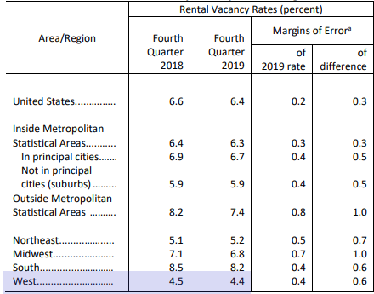

# Model Results

We built a Cash-flow model for both the properties and the results have been summarized below.

1. Property 1 (priced at $ 643,000) has a negative NPV for a discount rate of 12% for 30 years Mortgage payments

After recreating the NPV 1000 times through simulation, the average NPV is still negative. So its not an attractive investment opportunity.

**Average NPV after simulation = $ (78,000)**

1. Property 2 (priced at $ 499,990) has a positive NPV for the same discount rate of 12% for 30 years Mortgage payments

The distribution of NPV for Property 2 is shown below.

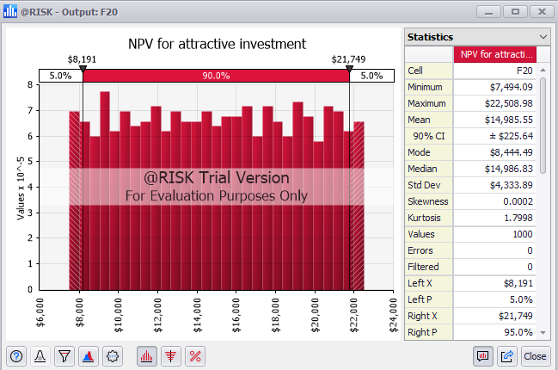

It is clear that there is 90% certainty that we will get an average of $ 14,985 as NPV after accounting for Uncertainty in Maintenance costs and initial Closing cost that are randomized in the model for a discount rate of 12%.

**The average NPV after simulation = $ 15,070**

At this stage, we realize that Property 2 is a better investment opportunity than Property 1 considering the positive NPV at the end of the mortgage period.

# Sensitivity Analysis for the property of our choice

Now that we have finalized that Property 2 is the attractive investment opportunity, we conduct a sensitivity analysis on the NPV randomizing the Annual Expected rate of rent increase and considering different values for the starting rent.

The reasons for choosing these variables are

1. Annual Expected rate of increase in rent is considered as a random variable that can take any value between 3% and 7%. We would like to know how sensitive is our NPV in case there is no consequent increase in the rent during uncertain market conditions.
2. We initially set the starting rent as $ 2,300 for our Property 2. We would like to know what would happen to our NPV for other values of the rent.

# Results of Sensitivity Analysis

After doing a sensitivity analysis using data table, we observed that the NPV of Property 2 is still positive even after accounting for uncertainties in Rental increase rates and starting rent prices.

Also, for the initial price that we chose in the beginning (i.e. $ 2,300), the rental increase has to be at least 4.5% annually.

Average NPV from the sensitivity table is given below.

|  |
| --- |
| **Average NPV from the Sensitivity table** |
| $ 18,502.64 |

Furthermore, the sensitivity analysis of NPV with changing annual rate of rent for initial rent as $2,300 showed the following trend.

Figure : NPV vs Rental increase rate per annum

# Conclusion

Thus, based on the simulation modelling and analysis, we see that [Property 2](https://www.redfin.com/WA/Lynnwood/14715-Admiralty-Way-98087/home/167339120#property-details) at 14715 B4, Admiralty Way, Lynnwood, WA 98087 is the better investment of the two. The model is available in the Appendix section.

# Appendix

Attached the Model below.

Model:



1. Source: <https://www.rentcafe.com/average-rent-market-trends/us/wa/bothell/>
2. Source: <https://www.rentcafe.com/blog/rental-market/apartment-rent-report/january-2020-national-rent-report/>
3. Source: <https://www.realpropertymgt.com/rental-property-maintenance-myths/>
4. Source: <https://www.thebalance.com/home-maintenance-budget-453820>
5. Source: <https://www.census.gov/housing/hvs/files/currenthvspress.pdf>